**Optimize heart excel file.**

1) **Learning rate = 0.1, Iteration = 10000, Test size = 0.1, Accuracy = 83 %**

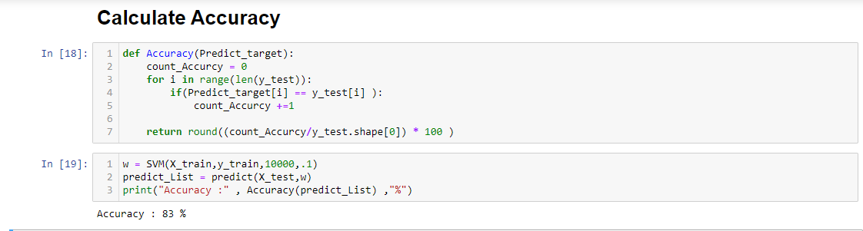

2) **Learning rate = 0.01, Iteration = 10000, Test size = 0.2, Accuracy = 75 %**

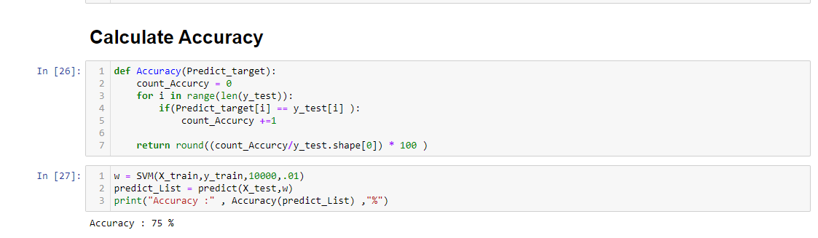

3) **Learning rate = 1 , Iteration = 13000 , Test size = 0.35 , Accuracy = 61 %**

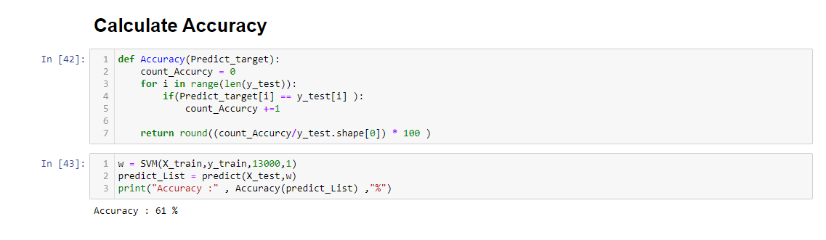

4) **Learning rate = 0.01, Iteration = 10000, Test size = 0.49, Accuracy = 58 %**

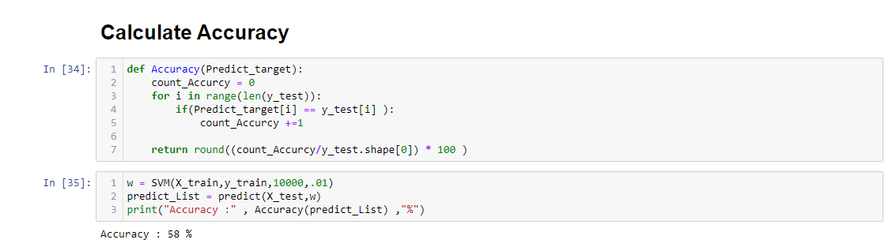

*5)* ***Learning rate = 0.001 , Iteration = 10000 , Test size = 0.9 , Accuracy = 55 %***

